**Worksheet 2.4: Methods, functions, selection and iteration**

**What will I learn by completing this worksheet?**

* Using built in methods (functions) and the ‘dot’ operator
* Writing your own functions
* If statements in JavaScript
* While loops in JavaScript
* Maths and logical operators

**Task 1 – User-defined functions**

1. Create a new HTML document with the following:

<html>

<head>

<title>Methods</title>

<script>

function details()

{

alert("Blah");

}

</script>

</head>

<body>

<b> Methods example Page</b> <br>

<form name="DetailsForm">

Enter full name

<input type ="text" id="fullname">

</br>

<input type = "button" value="ClickMe" onClick="details()">

</form>

</body>

</html>

2. Run it in the browser to see what it does.

3. Try sending the name entered as a parameter to details().

You can access the name in the form using its ID so you would send it as details(fullname.value) on click. Remember to alter the function to receive the parameter e.g. function details(name), so in the function their full name is now stored in a variable called name.

what happens if you don't send a parameter but instead try to output fullname.value from the details() function.?Compare the result in MSIE and Chrome and keep a record with screen grabs.

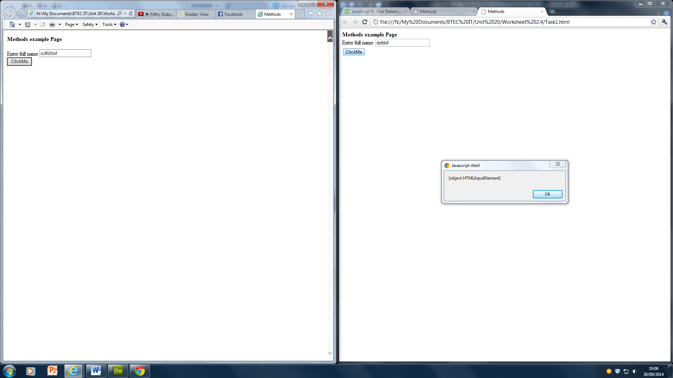

IE doesn’t display the alert box at all were as chrome does but with an error

4. Functions can also return values (you know this from other units). One built-in function is prompt(msg). Change details() so that it displays a prompt box for the user’s name and assigns what it returns to a new variable, which you can then displayed in the alert message box. For example:

Var name = prompt(‘enter your name’);

5. What happens if you change the event trigger for the button form onClick to onMouseOver? Try some other ones from the complete list <http://www.irt.org/articles/js058/>.

**Task 2 – If..else statements in JavaScript (Guess the word)**

If statements in JavaScript: <http://www.w3schools.com/js/js_if_else.asp>

Start a new HTML page.

1. Within the <head> tag write a new function that asks a user for the secret word using a **prompt** window and stores their guess in a **variable** called **guess**.
2. Using an **if statement**, check to see if the word they entered is the same as the secret word (you can decide what this word is!)
3. If they have guessed correct **alert** them to this
4. **Else** if they have guessed incorrectly **alert** them of this

Paste the code and screen grabs here:

**Task 4 –Switch/Case in JavaScript**

You have covered these before as case/select in VB.NET. Can you remember when we use them?

Look at <http://www.w3schools.com/js/js_switch.asp>

1. Write some HTML that gets the user to select a day of the week from a dropdown list box Look at Task 1 if you have forgotten how to do a drop down or checkout the example switch dropdown code on Moodle.
2. Write a script on the page that is run when the dropdown option is changed (you’ll need to find a suitable event handler from the link in Task 1.

Paste the source code and screen grabs here:

1. Now return to the code for Task 1 and modify the code for (5) so that it outputs male or female depending on the number of the option selected (rather than 0 or 1 being output).

**Task 5 – Maths and logical operators**

+ plus - minus

* multiply / divide

> greater than < less than

++ increment by 1 -- decrement by 1

== checks if equal != not equal

>= equal to or less than

Create a script to:

1. Add two numbers together the user enters and output the result
2. Increment a number entered by the user by 1
3. Check if two numbers enter by the user are equal

Paste the completed scripts here with screen grabs of them running:

**Task 6 – While loops in JavaScript (extra for homework)**

While loops in JavaScript: <http://www.w3schools.com/js/js_loop_while.asp>

Working on the same HTML as task 2:

1. Adapt the script so that **while** the user has not guessed correctly, it keeps **prompt**ing for another guess. Hint: you’ll need a new **Boolean** variable set initially to false.

For the experts:

1. In addition to the above, adapt the script so that after 4 guesses an appropriate **alert** is displayed and the game is over.
2. Revisit your **array** skills from an earlier worksheet extension and adapt the script so that each of the user’s guesses is stored in an array of 4 elements. Have these 4 wrong guesses displayed in the alert for (2).

**Extra Task – More work with built-in object methods**

There are many functions and libraries (which we’ll look at another time) available and you’ll need to learn about them as and when you need them.

String replacement is one useful function. Read <http://www.w3schools.com/jsref/jsref_replace.asp> and then complete the following:

1. Create a new web page and in the body, write a script that prompts the user to enter ‘Richard Huish College’ and assign this to a variable. Pass this variable as a parameter to a function called promotion().
2. Write a function in the <head> of the page called promotion() that replaces the word ‘College’ with ‘University’ and outputs the new string to an alert window

Paste your code and a screen grab of it working here:

1. Modify the code so that a new variable in the script in the body is assigned the new string returned by the promotion() function and then this new string is written to the browser window.  
   Hint: to return a value simple write ‘return variableName’ in the function.

Paste your code and a screen grab of it working here: